Table of Contents
1. Introduction 1
1.1. Existing System 2
1.2. Need for the New System 2
1.3. Objective of the New System 2
1.4. Problem Definition 3
1.5. Core Components 3
1.6. Project Profile 4
1.7. Assumptions and Constraints 4
1.8. Advantages and Limitations of the Proposed System 5
2. Requirement Determination & Analysis 6
2.1. Requirement Determination 6
2.2. Targeted Users: 6
3. System Design: 8
3.1. Use Case Diagram: 8
3.2. Class Diagram: 9
3.3. Interaction Diagram 10
3.4. Activity Diagram 19
3.5. Data Dictionary: 25
4. Development: 28
4.1. Coding standards: 28
5. Agile Documentation: 37
5.1 Agile Project Charter 37
5.2 Agile Roadmap / Schedule: 38
5.3 Agile Project Plan: 38
5.4 Agile User Story: 39
5.5 Agile Release Plan: 41
5.6 Agile Sprint Backlog: 42
5.7 Agile Test Plan: 43
5.8 Earned-Value Burned Chart: 46
6. Proposed Enhancement: 47
7. Conclusion: 48
8. Bibliography: 48

Introduction

This document outlines the functionalities and benefits of an Inventory Management System (IMS). An IMS acts as a centralized hub for managing your stock, offering real-time information on item quantities and locations. This eliminates the need for manual tracking and scattered data, providing a clear picture of your inventory levels. By implementing an IMS, businesses can expect improved cost control through minimized storage expenses and optimized stock levels.

Existing System

Traditionally, inventory management relied on manual methods like spreadsheets, physical counts, and manual bill generator. This approach is prone to errors, time-consuming, and becomes increasingly cumbersome as businesses grow and their inventory complexity increases. These limitations highlight the need for a more efficient and automated solution, which is precisely where Inventory Management Systems (IMS) come into play.

Need for the New System

Given the complexities of managing electronic items, our current inventory system's manual processes and lack of real-time data are inadequate. These shortcomings lead to delays in order fulfillment and stockouts, compromising customer satisfaction and hindering our competitiveness. Upgrading to a modern electronic-specific inventory management system is essential to streamline operations, reduce costs, and stay ahead in this fast-paced industry.

Objective of the New System

- Invoice Generation: The primary objective of the new system is to facilitate the generation of invoices seamlessly. This includes automating the process of creating and sending invoices to customers upon order completion.
- Stock Management: Another key objective is to enhance stock management capabilities. This involves real-time tracking of inventory levels, monitoring stock movements, and implementing automated alerts for low stock levels to ensure timely replenishment.
- Order History: The system aims to maintain comprehensive order history records. This enables users to access past orders easily, view order details, track order status, and analyze historical data for better decision-making.
- Search Functionality: A crucial objective is to incorporate an efficient search function within the system. This feature allows users to quickly locate products, orders, invoices, or other relevant information, enhancing user productivity and efficiency.
- Product Management: The system seeks to improve product management by providing tools for adding, updating, and categorizing products efficiently. This includes features for managing product attributes, pricing, and specifications.
- Brand Management: An objective is to implement brand management functionality within the system. This involves categorizing products by brand, managing brand information, and facilitating brand-specific reporting and analysis.
- Category Management: Lastly, the system aims to enhance category management capabilities. This includes organizing products into logical categories, managing category hierarchies, and facilitating category-based reporting and analysis.
- Payment Modes: It shows that how the customer had paid the bill in advance, full payment, not paid and all the information.
- Downloadable PDF Invoices: Another objective is to allow customers to easily receive downloaded PDF invoices directly.

Problem Definition

- Manual processes: Inefficient and error-prone manual tracking of stock levels, order placement, and stock locations.
- Inaccurate data: Outdated or unreliable data leads to poor decision-making regarding inventory management.
- Stockouts and excess inventory: Inability to predict demand accurately can result in stockouts leading to lost sales and customer dissatisfaction, or excess inventory incurring storage costs and reducing cash flow.
- Limited visibility: Lack of a centralized system makes it difficult to track inventory across multiple locations and manage stock flow effectively.

Core Components

      - MANAGE BRAND:
This IMS portal is mainly use for mobile store. Which has functionalities of add, update, delete brands likes Samsung, iphone and LG and product with stock management.
      - MANAGE CATEGORY:
This IMS portal is mainly use for mobile store. Which has functionalities of add, update, delete categories likes mobile phones and laptops and product with stock management.
- MANAGE PRODUCT:
This IMS portal is mainly use for mobile store. Which has functionalities of add, update, delete products with stock management.
- MANAGE INVOICE:
Invoicing and billing application for different business purposes helps mainly the service providers and freelancers to manage and track their payment status. This IMS is mainly use for mobile store which has functionalities of generating invoice.
- GENERATE REPORT:
Admin will be able to generate yearly, quarterly, monthly collection report as per the need.

Project Profile

Project Title | INVENTORY MANAGEMENT SYSTEM
Duration | 3 Months
Project Internal Guide | Prof. Rita Gokani
Front End | CSS, HTML, Bootstrap
Backend | MySQL, PHP
Operating System | Window 11

Assumptions and Constraints

Assumptions:
Data Accuracy: The system relies on accurate and up-to-date product information, including item descriptions, unique identifiers (SKUs), and quantities.
Data Integrity: Inventory data needs to be entered and maintained consistently. This ensures the system operates on reliable information and minimizes errors.
User Access Controls: Clearly defined user roles and permissions are crucial for data security. This ensures only authorized personnel can access and modify inventory data.
System Integration: An effective IMS integrates seamlessly with other relevant business applications such as accounting and sales software. This promotes data flow and eliminates the need for manual data entry across various systems.
Constraints:
Data Accuracy: An IMS is only as good as the data it receives. Inaccurate or inconsistent data entry can lead to misleading inventory levels and hinder the system's effectiveness.
System Limitations: While IMS offer automation, complex business rules or specific needs might require customization beyond the system's base functionalities.
Integration Challenges: Integrating an IMS with existing enterprise software (ERP, accounting) can be complex and require additional resources.
Implementation Costs: The initial investment in acquiring and implementing an IMS can be significant, especially for larger businesses.
User Adoption: Successful utilization requires proper training for staff to effectively navigate the system and leverage its features.

Advantages and Limitations of the Proposed System

Advantages:

- All operations are accurate and user friendly. A modern approach to work in less time.
- Facilitate to maintain Stock and records.
- We get Proper Details on Inventory.
- Easy to maintain Product.
- Lead Time Awareness for acquiring new stock.

Limitations:
- Stock must be always updated.
- Technology Constraints works with specific type of hardware-based
- System cannot be customized.
- Always need a person to update the system and generate an invoice.

Requirement Determination & Analysis

Requirement Determination

⮚ Hardware Requirement:

● Intel(R) Core (TM) i5-6040U CPU@ 2.3GHz
● 4GB Ram
● Hard Disk 1GB(HDD)

⮚ Software Requirement:

● Operating System: Windows 11
● Database: MySQL Xampp
● Development Tool: Visual Studio Code

Targeted Users:
    - Admin
- The administrator who oversees operating this system and can make changes in system.

  - Proposed Timeline Chart:
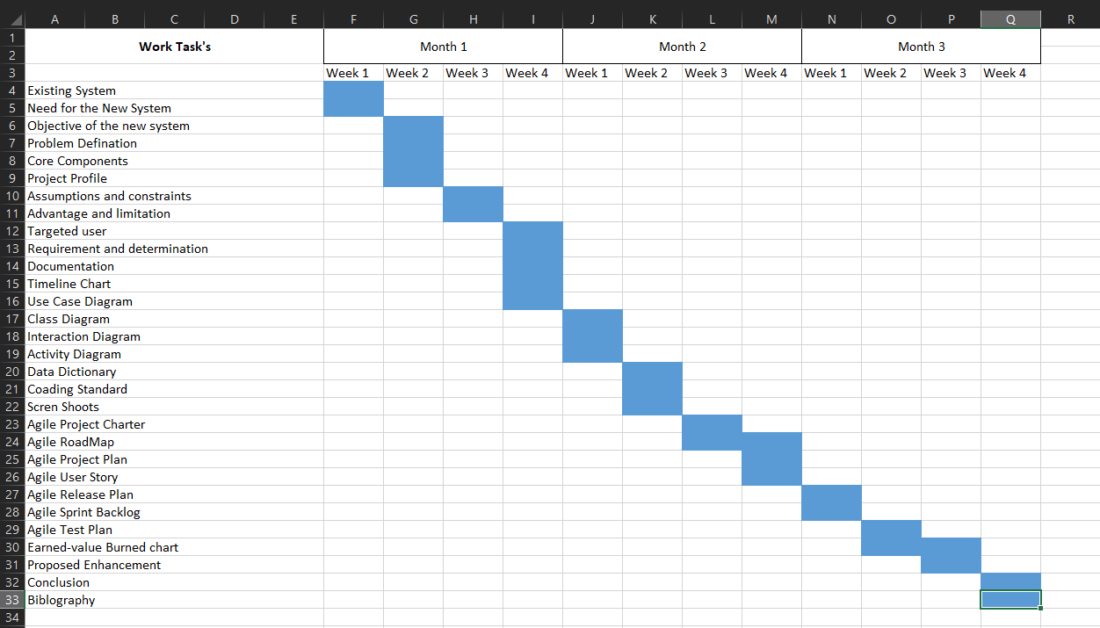

3. System Design:

3.1. Use Case Diagram:

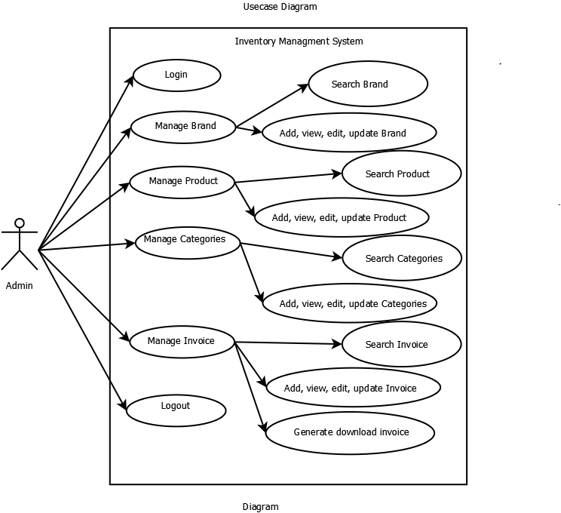

3.2. Class Diagram:
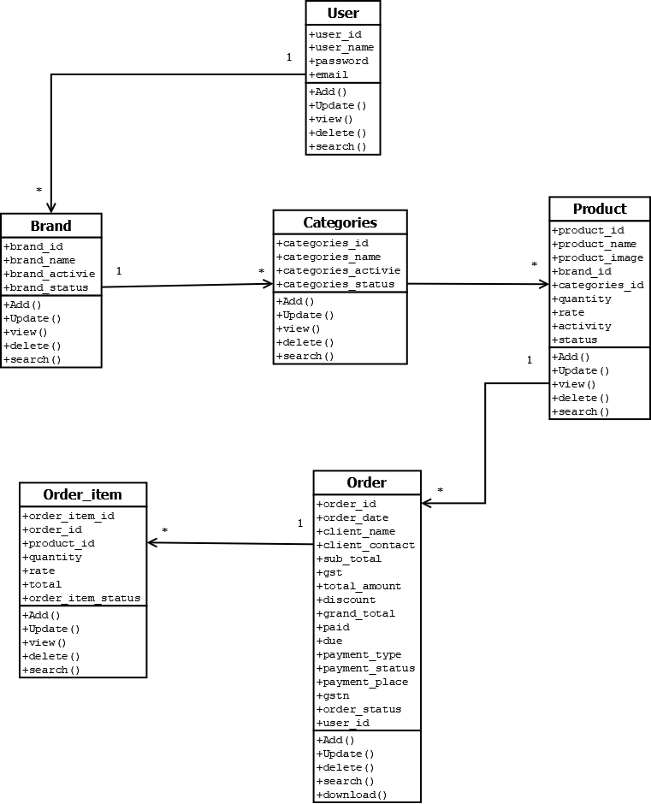

3.3. Interaction Diagram
- Interaction Diagram for Login System:

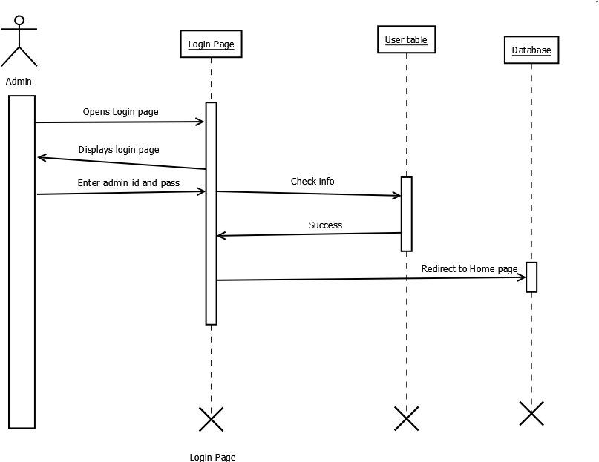

- Interaction Diagram for Add Brand:

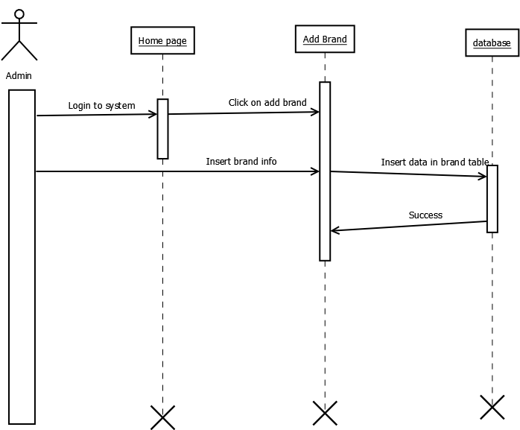

- Interaction Diagram for Manage Brand:
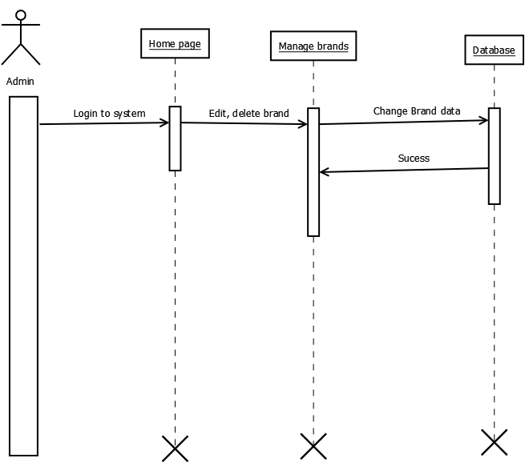

- Interaction Diagram for Add Categories:
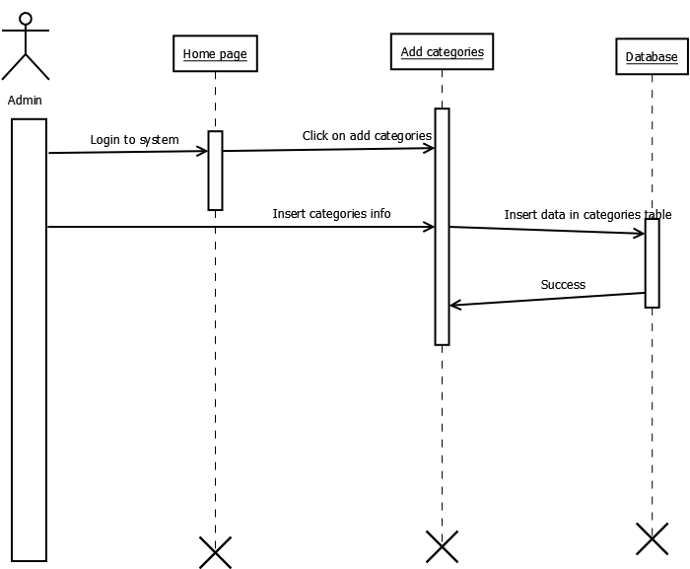

- Interaction Diagram for Manage Categories:
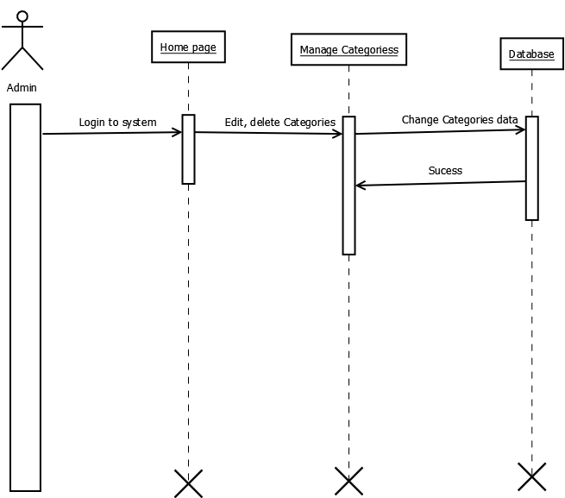

- Interaction Diagram for Add Product:

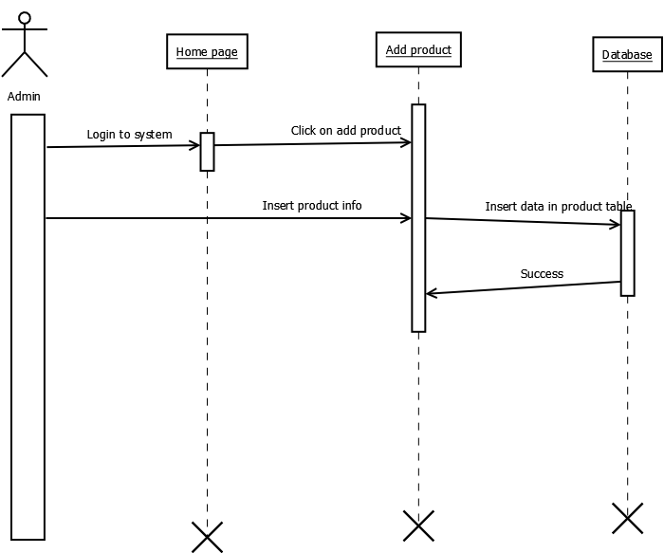

- Interaction Diagram for Manage Product:

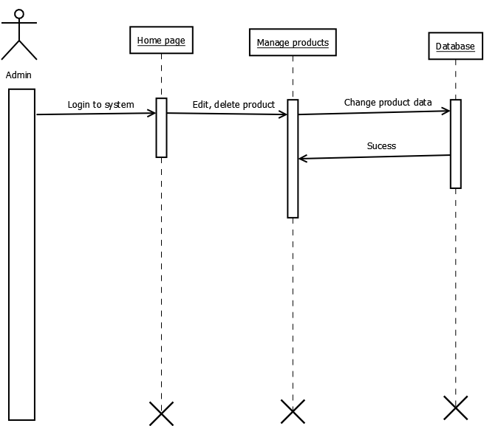

- Interaction Diagram for Add Invoice:

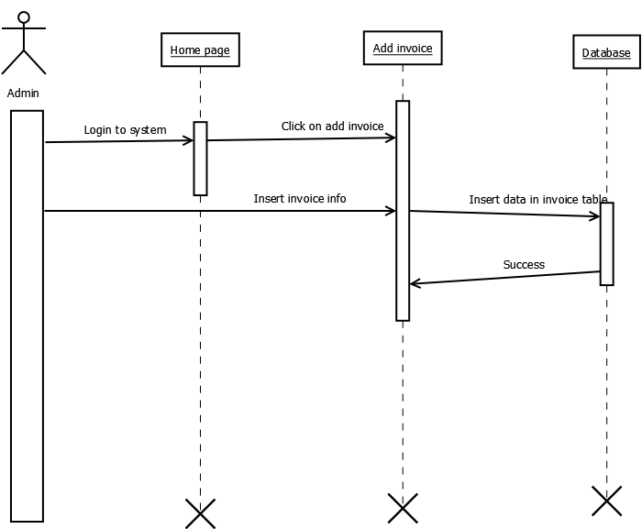

- Interaction Diagram for Manage Invoice:
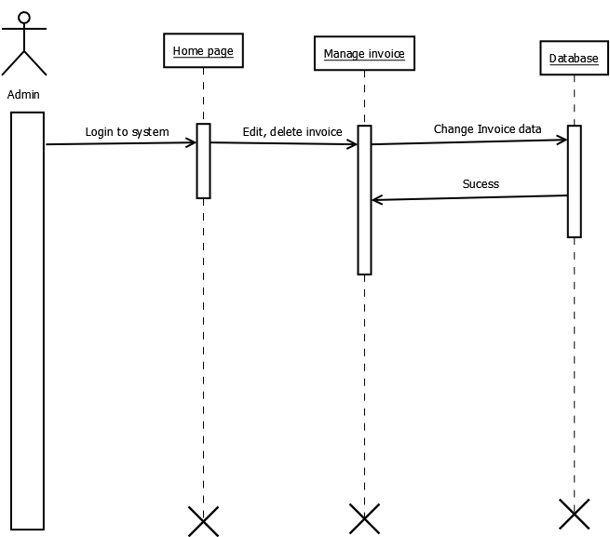

- Interaction Diagram for Download Invoice:
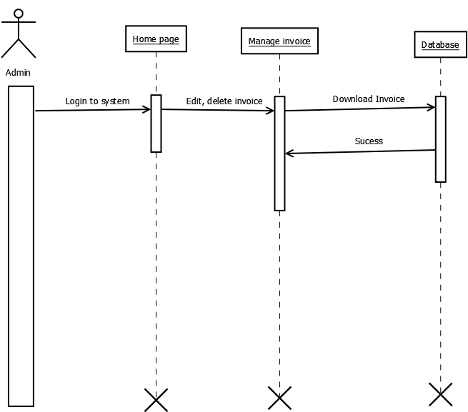

3.4. Activity Diagram
- Activity Diagram for Login:

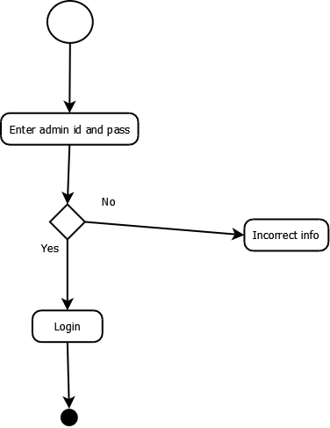

Activity Diagram for Manage Brand:
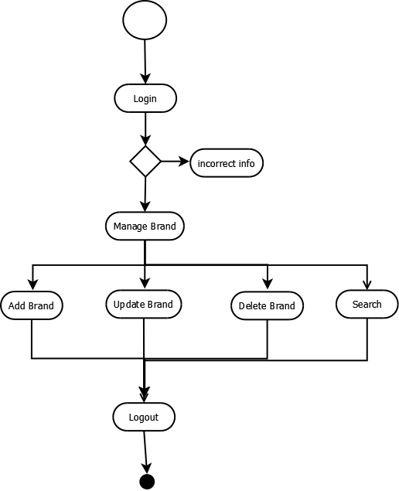

Activity Diagram for Manage Categories:
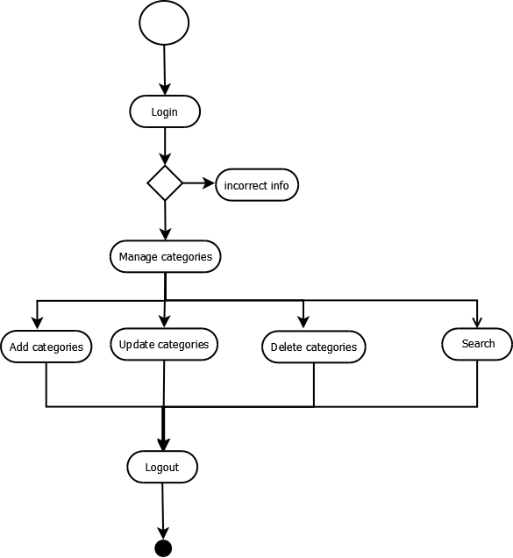

Activity Diagram for Manage Product:
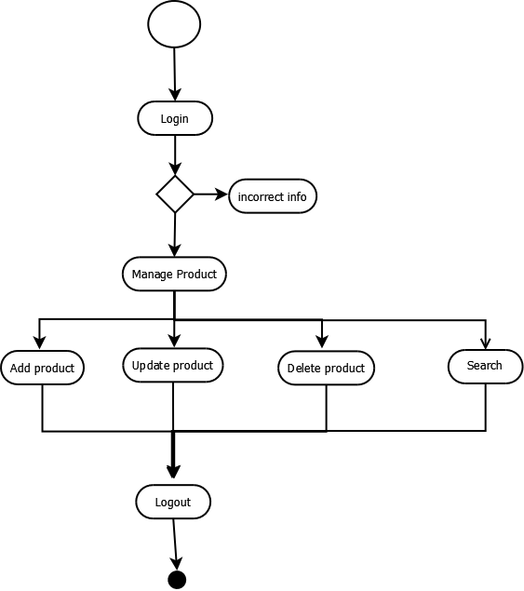

Activity Diagram for Manage Invoice:
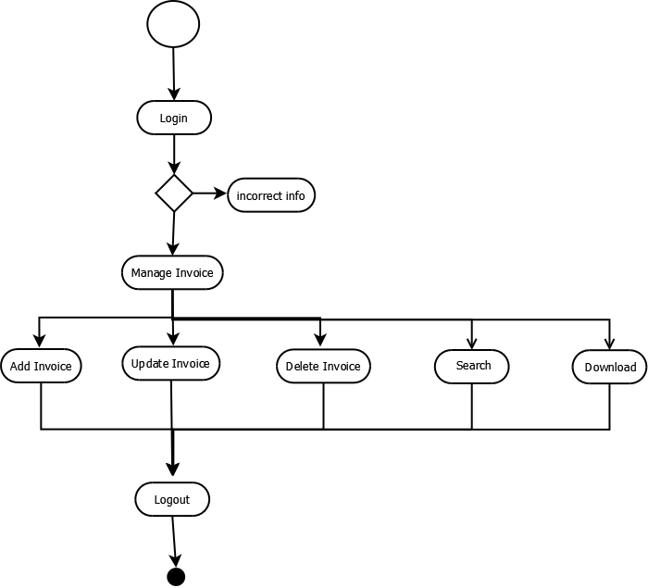

3.5. Data Dictionary:
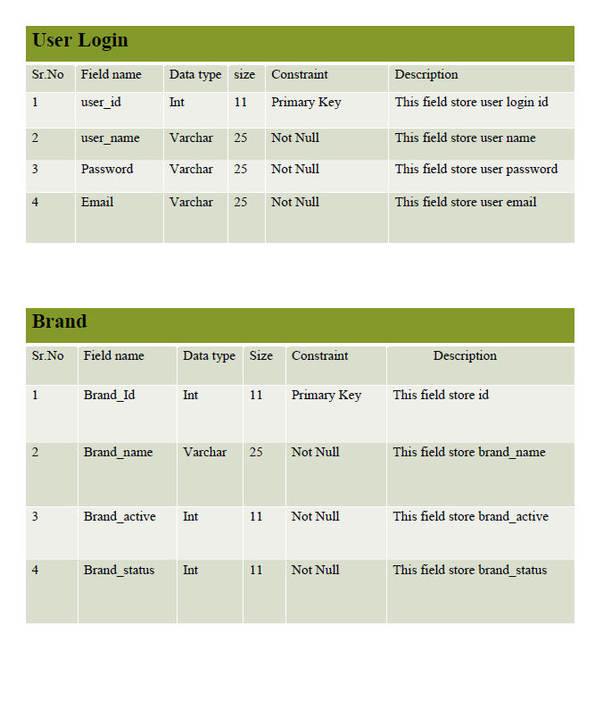

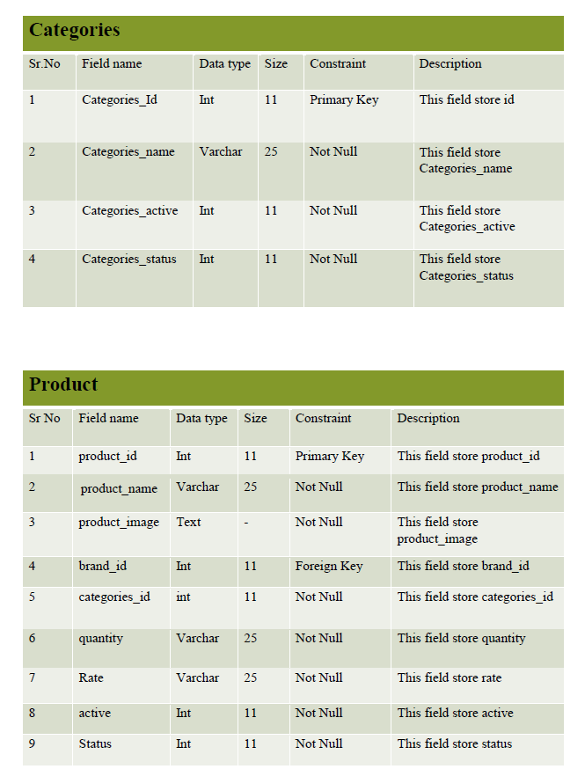
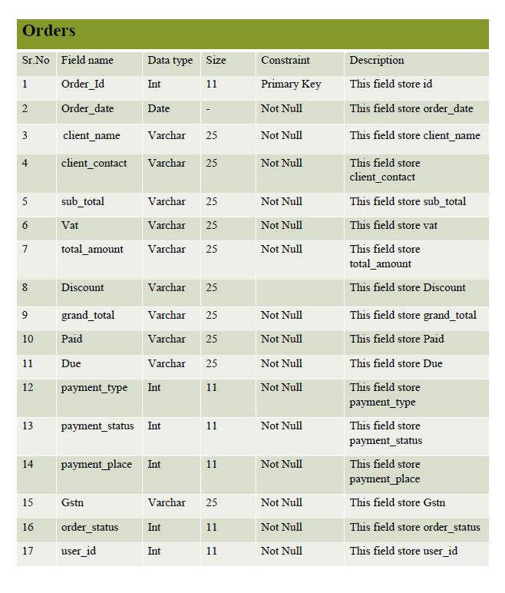

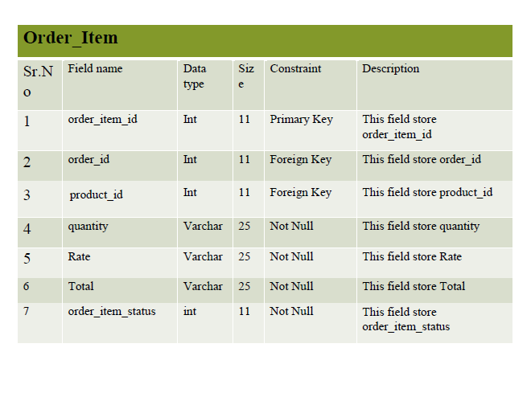

4. Development:

4.1. Coding standards:
1. Follow naming conventions in variable name and methods name.
2. Give minimum two spaces between operator and operand.
3. Give proper indentation.

(1) addBrand.php
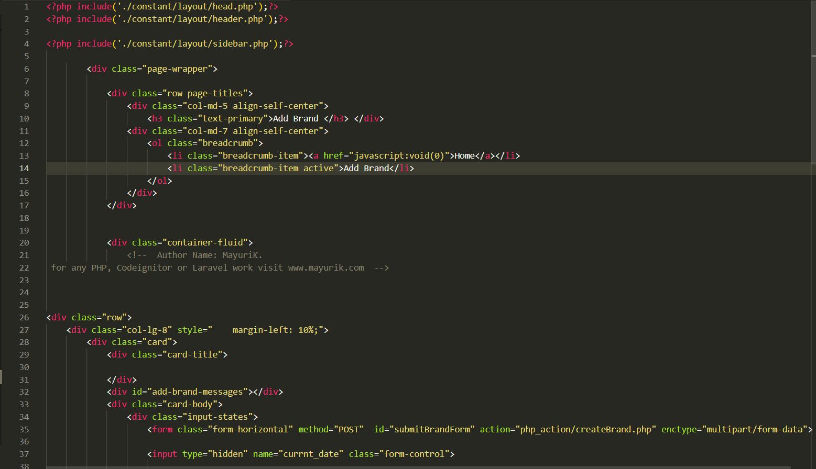

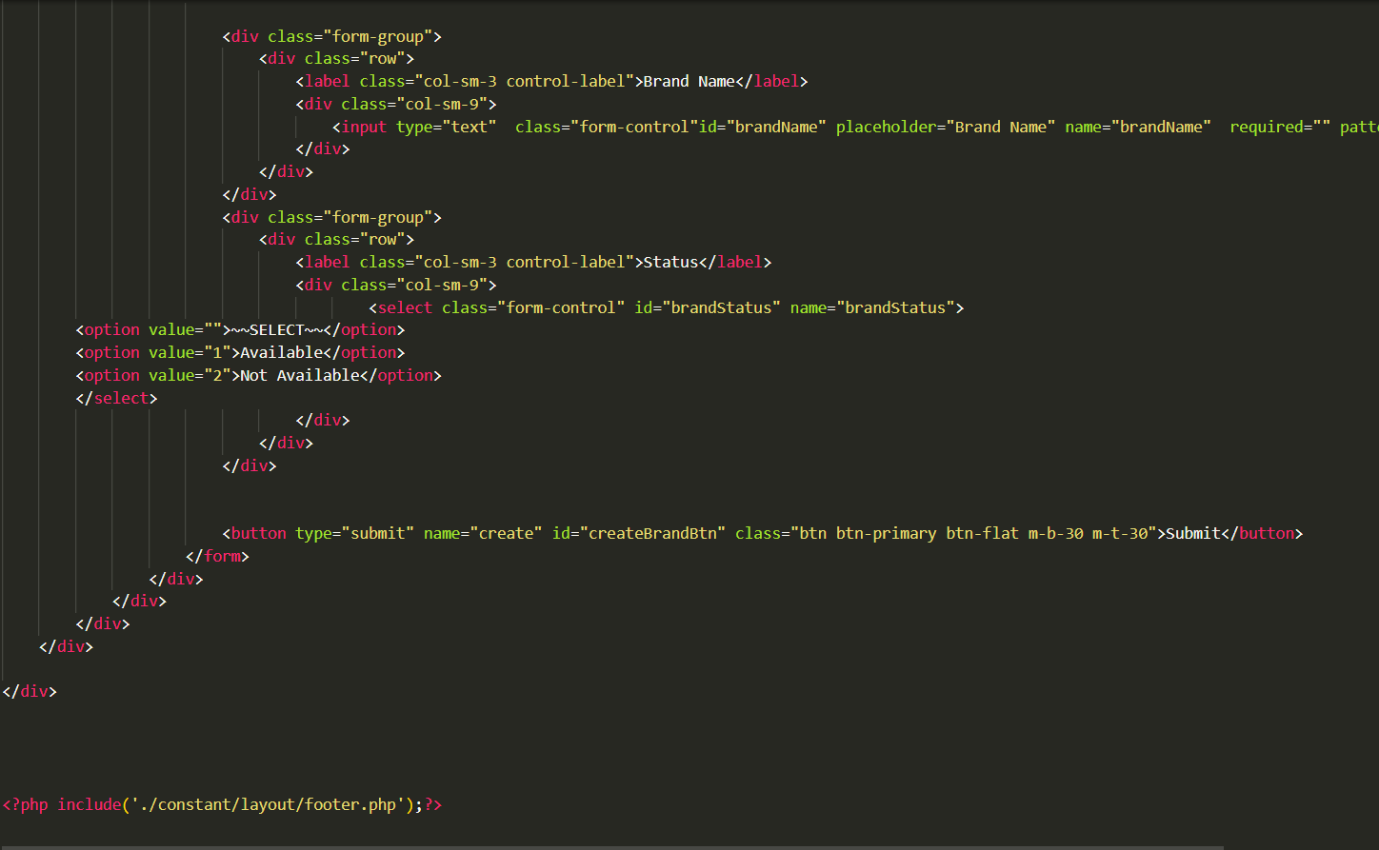

(2) createbrand.php
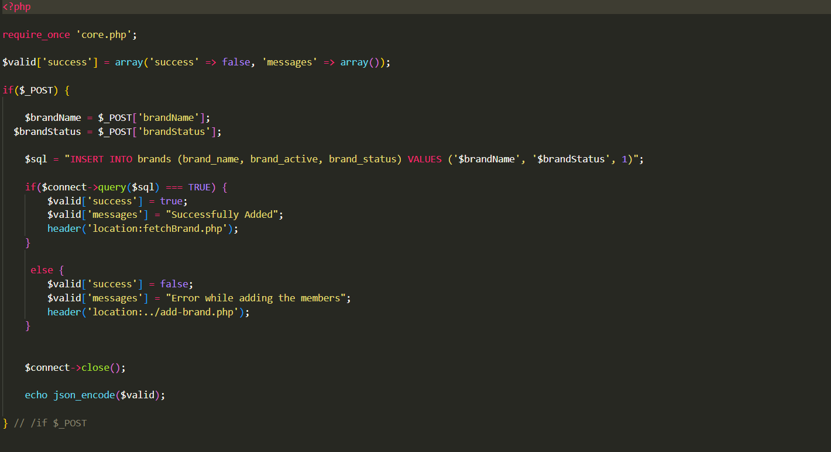
4.2. Screen shots:
Home page:
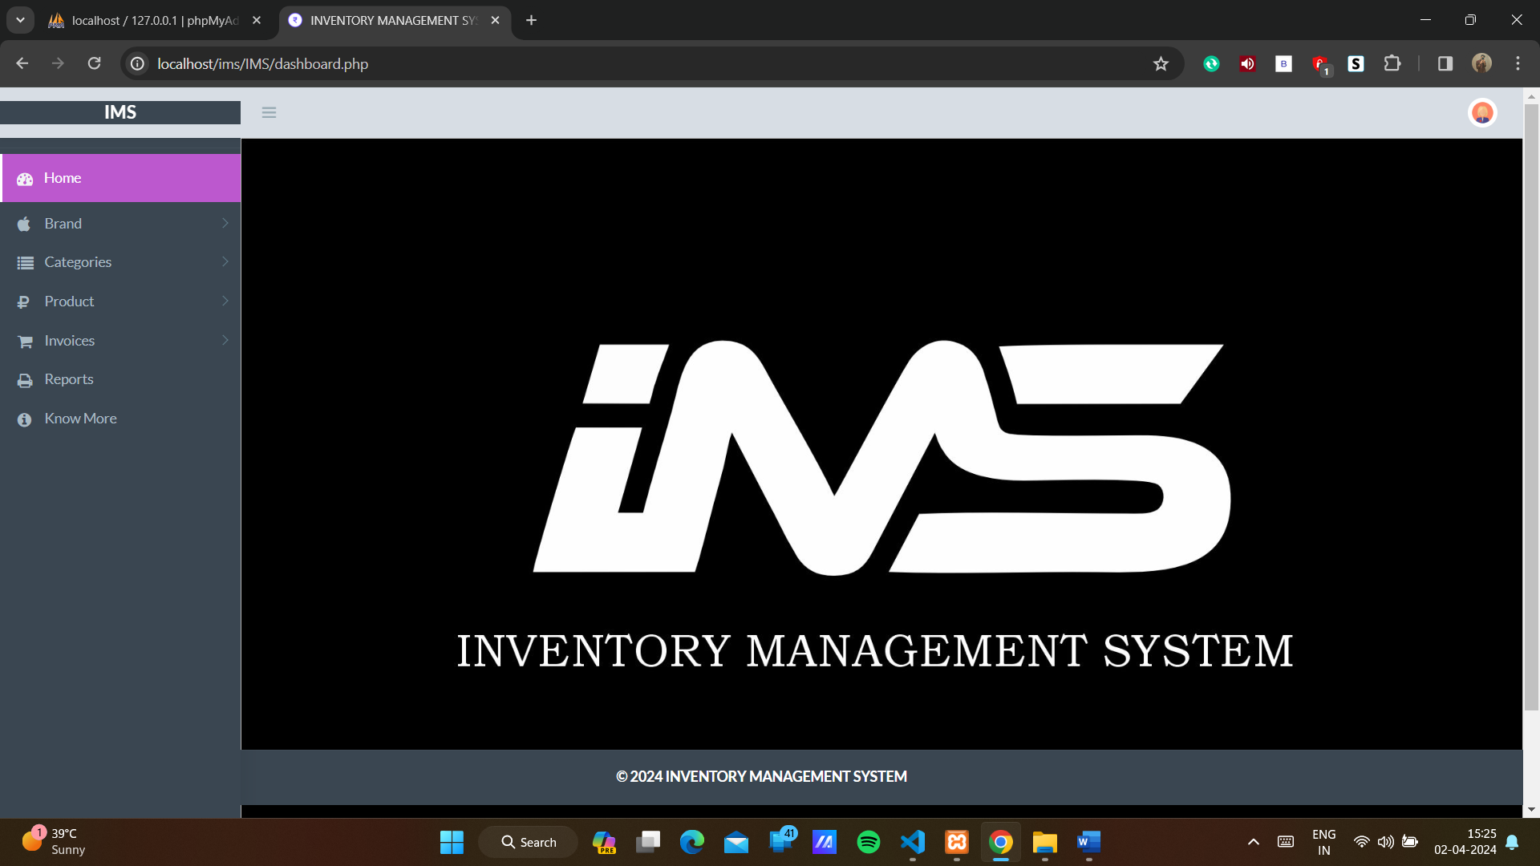
Add brand page: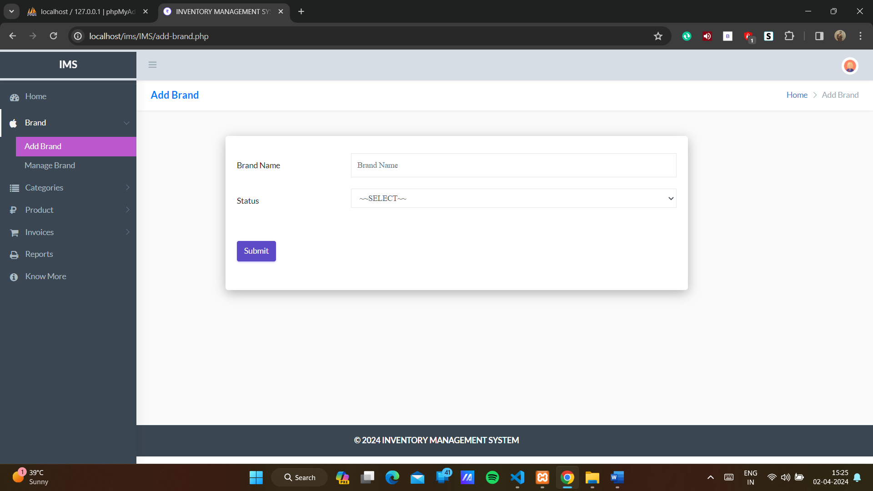

Manage Brand page: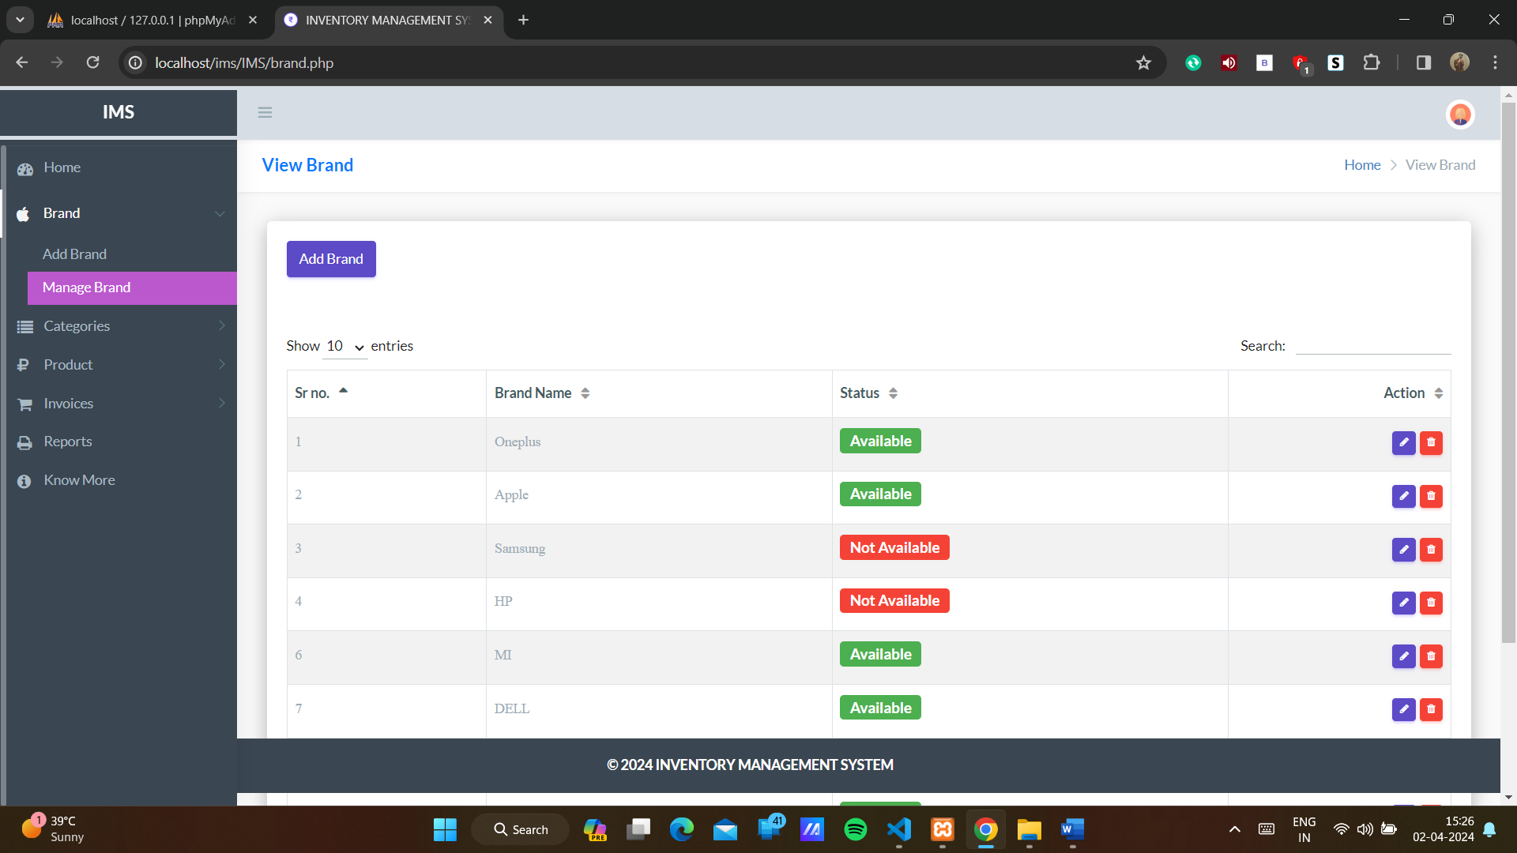Add category page: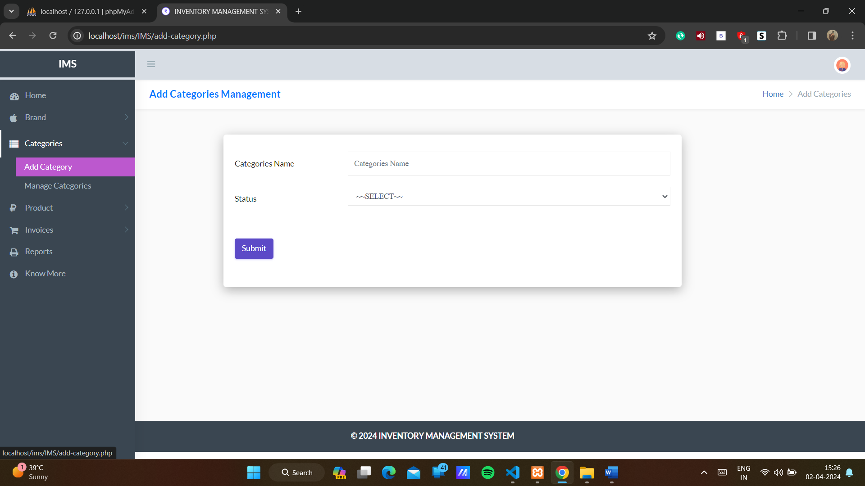

Manage category page: 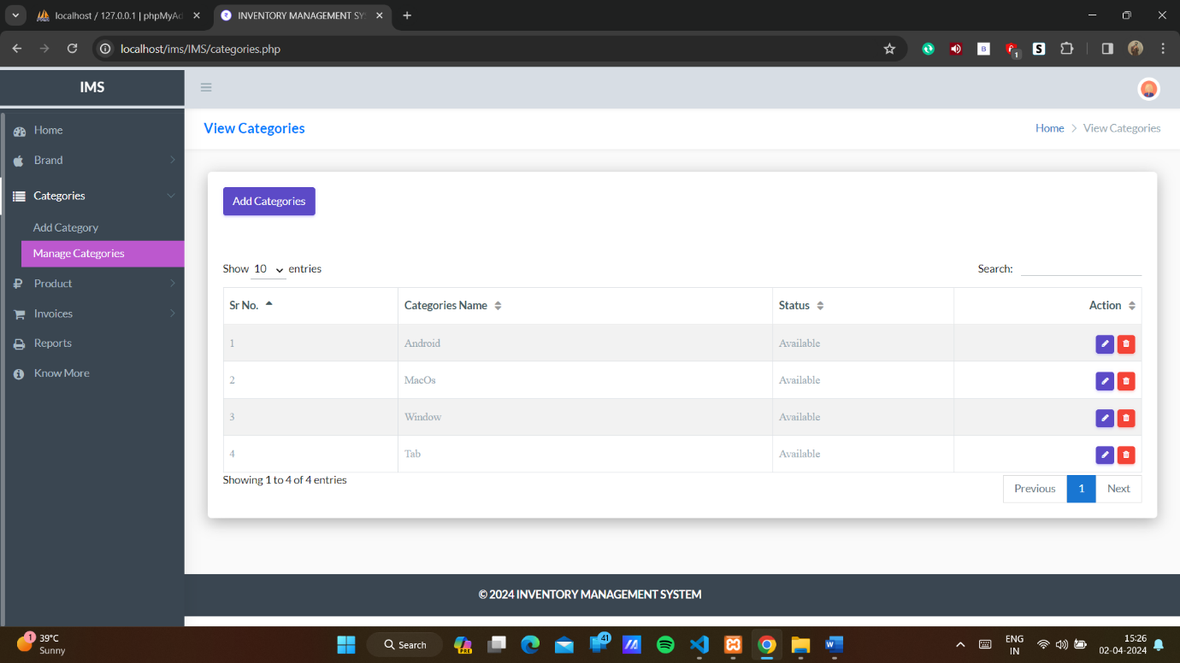
Add product page: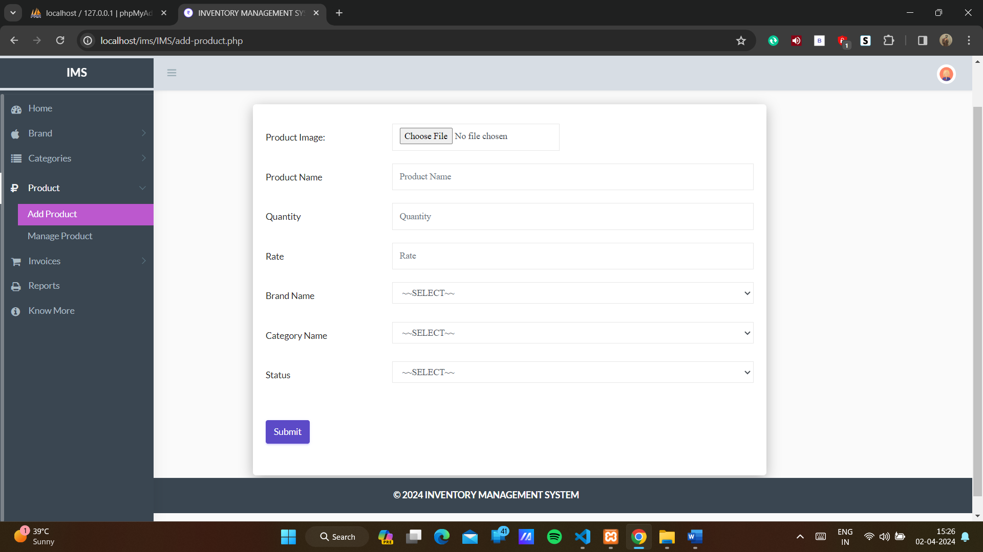

Manage product page: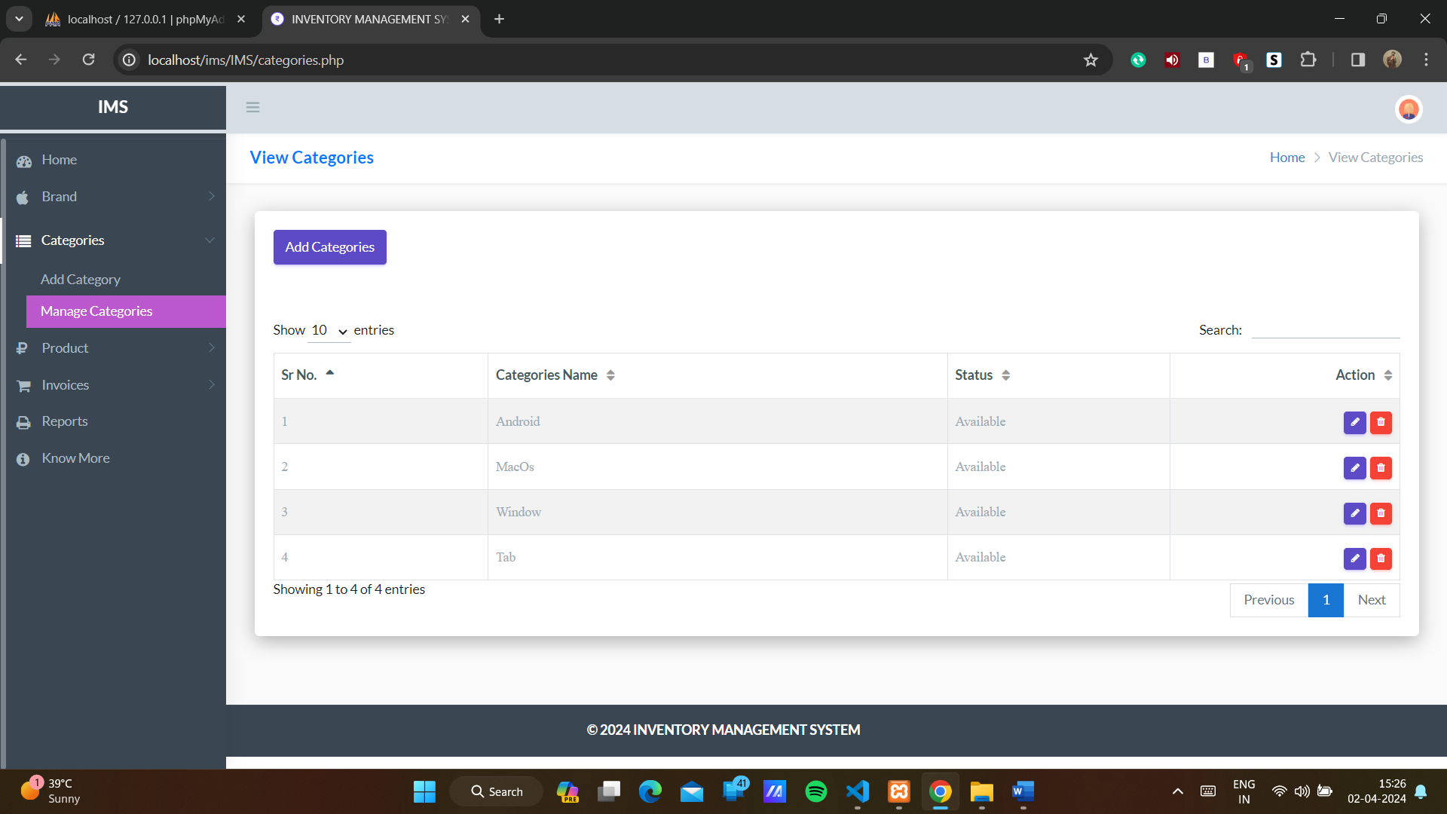
Add invoice page: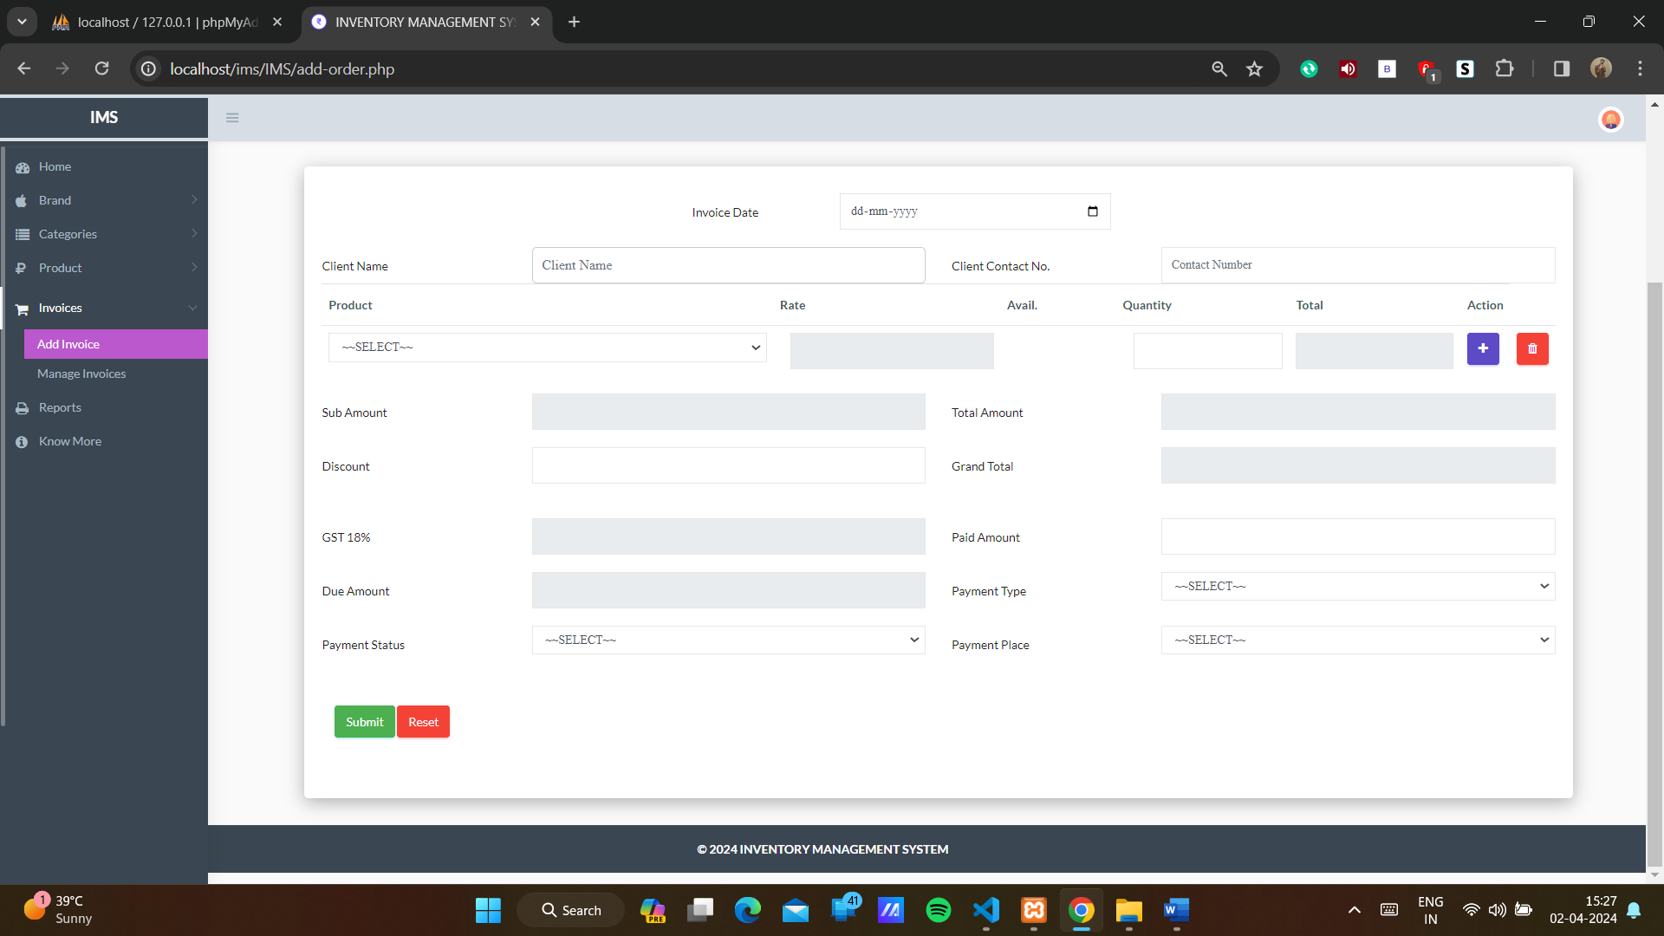

Manage invoice page: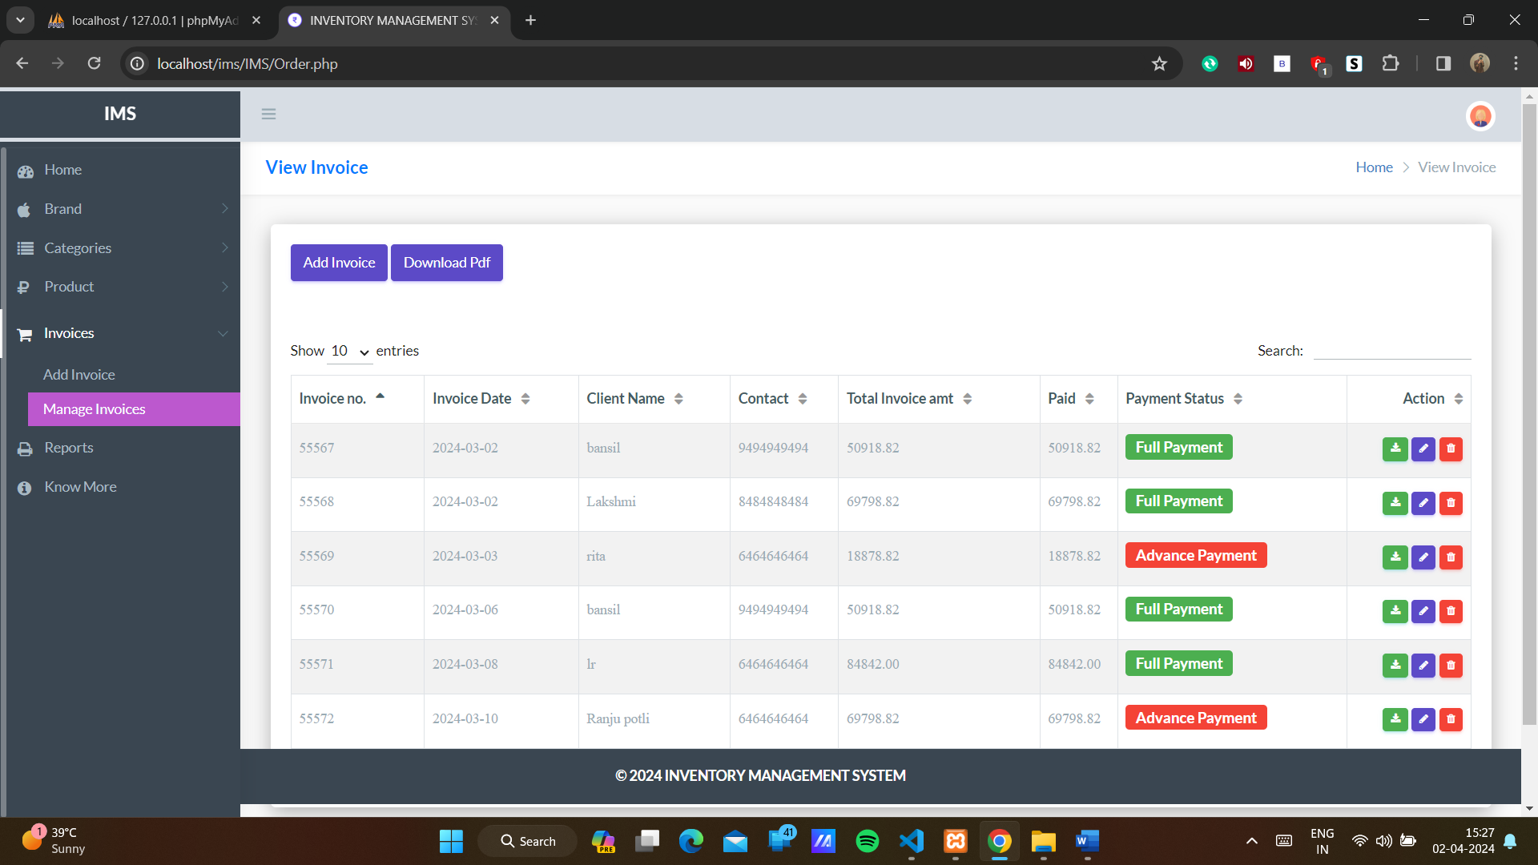
Report page: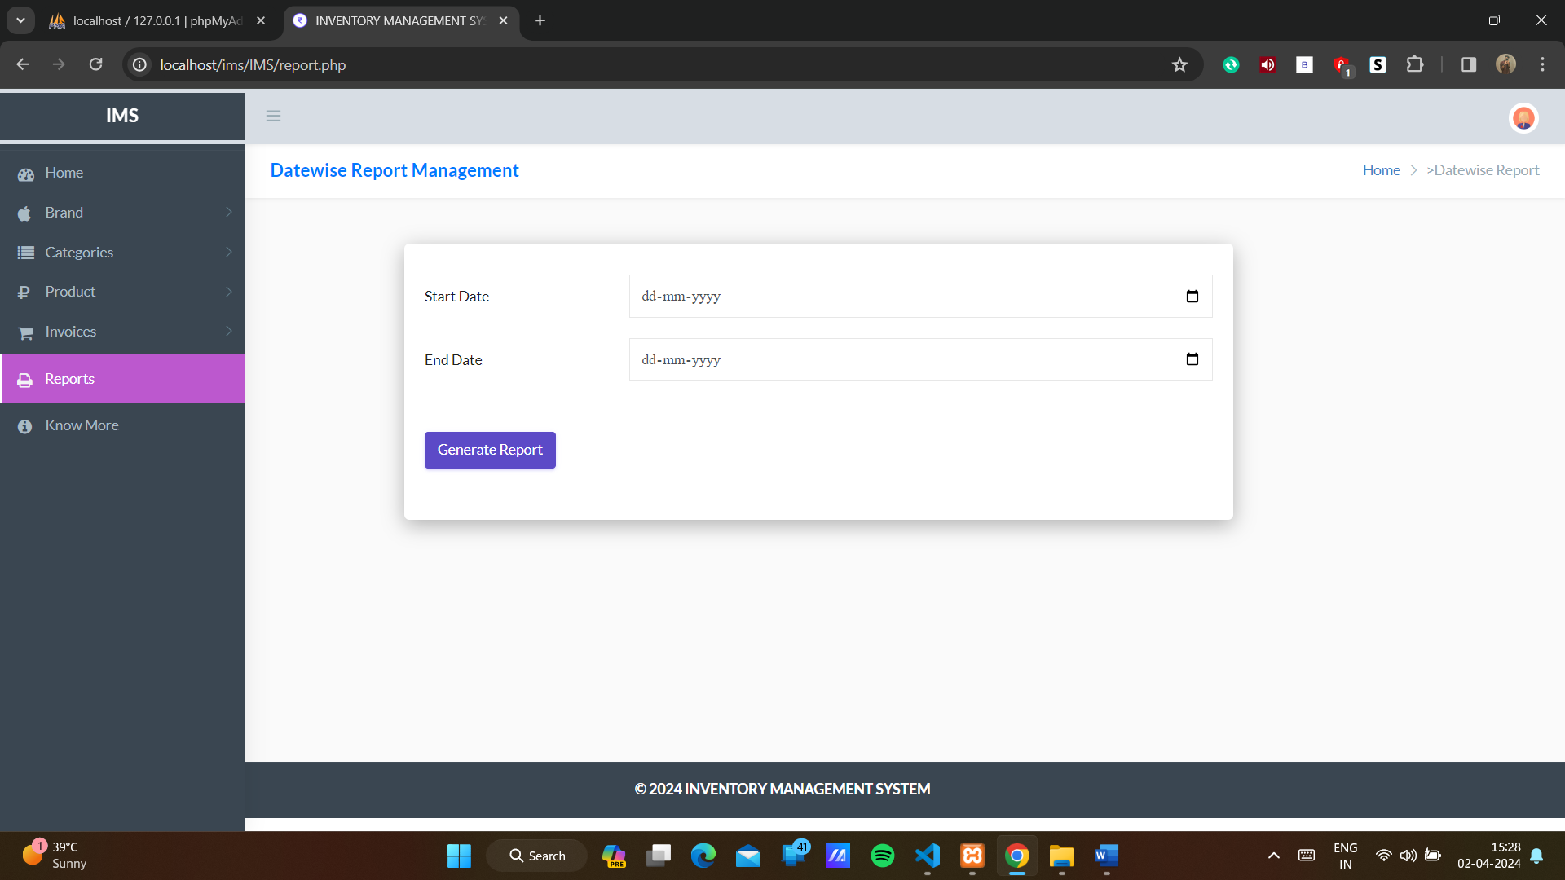
Generate report page: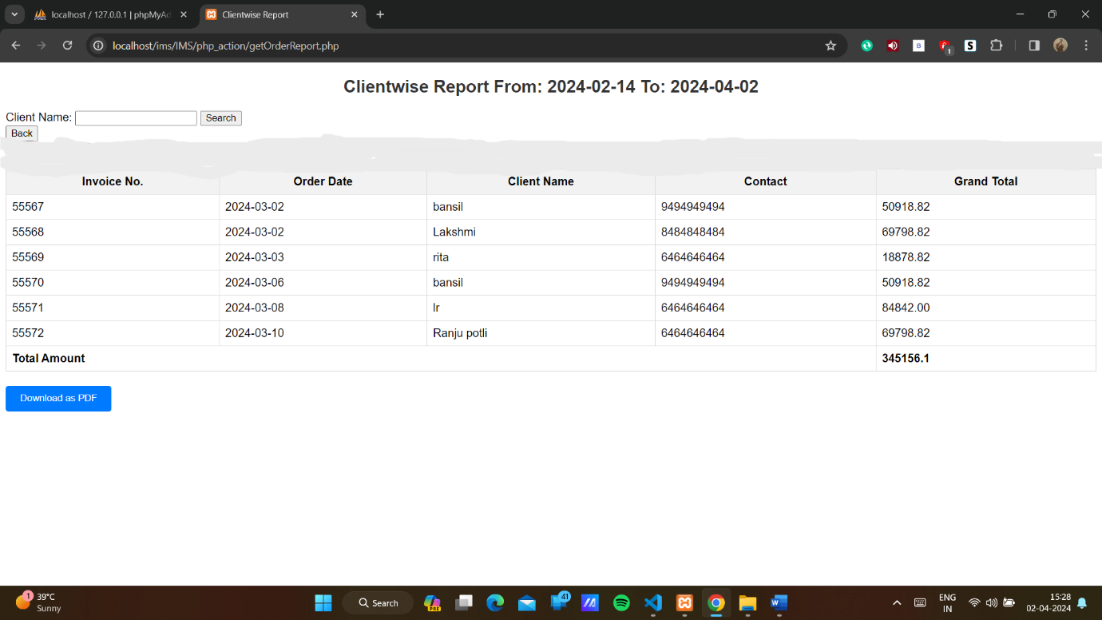
Report Download as pdf page: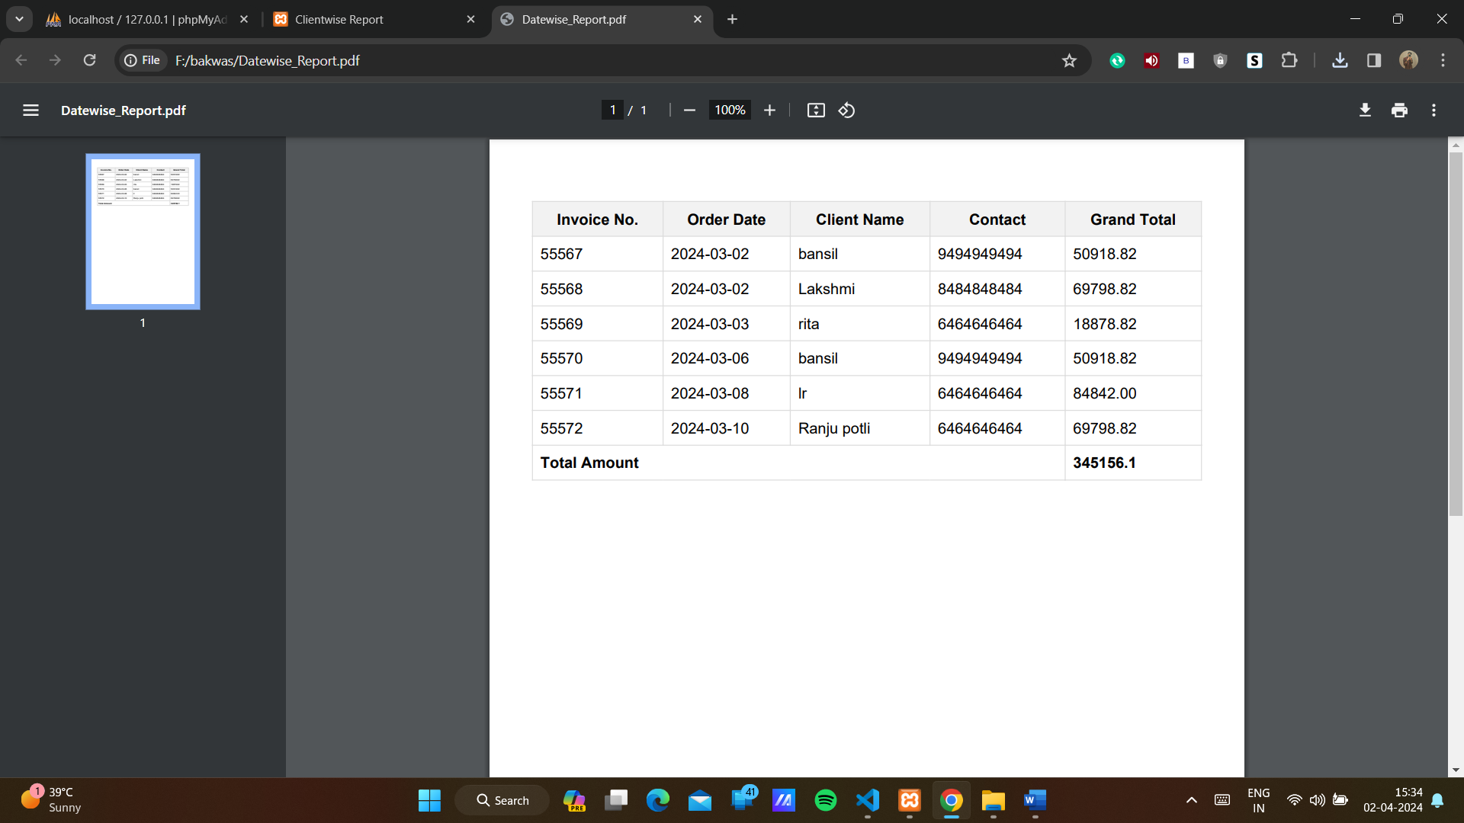
Contact page: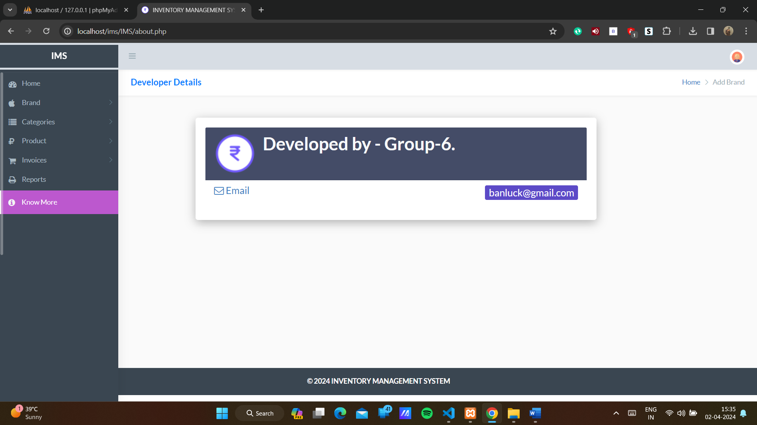

5. Agile Documentation:

5.1 Agile Project Charter

General Project Information
Project Name | Inventory Management System
Project Champion | Bansil Pabari, Lakshmi Renju
Project Sponsor | LJ Institute of Computer Application
Project Manager | Prof Rita Gokani
Stakeholders | Admin
Expected Start Date | 09/01/2024
Expected Completion Date | 05/04/2024

Project Details
Mission | The aim of creating an inventory management system is to effectively track, manage, and control inventory levels, ensuring accurate stock information, streamlined operations, and optimized supply chain processes to meet customer demand efficiently.
Vision | The vision for an inventory management system is to become the industry standard solution, revolutionizing inventory control with cutting costs empowering businesses to achieve their fullest potential in supply chain management and customer satisfaction.
Scope | Admin can deal in a wide range of courses. They can analyse customer buying patterns and preferences and maintain the stock early, can give discounts. Business can be easily scaled.
Date | 05/04/2024

5.2 Agile Roadmap / Schedule:
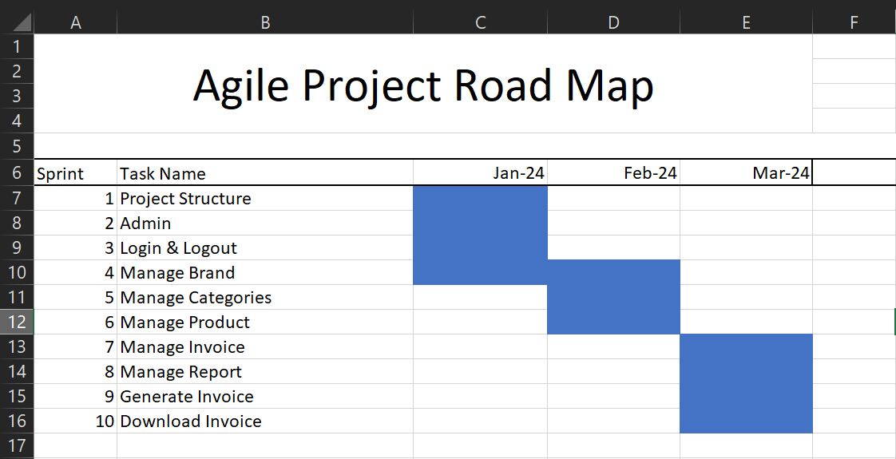

5.3 Agile Project Plan:

Task Name | Duration | Start | Finish | Status
Sprint#1 : Project Structure | 6d | 09/01/2024 | 14/01/2024 | Completed
UI Designing | 4d | 15/01/2024 | 18/01/2024 | Completed
Database Management | 4d | 19/01/2024 | 22/01/2024 | Completed
Sprint#2 : Admin | 6d | 23/01/2024 | 28/01/2024 | Completed
Admin UI Designing | 2d | 29/01/2024 | 30/01/2024 | Completed
Sprint#3 : Login and Logout | 1d | 31/01/2024 | 31/01/2024 | Completed
Admin Login | 1d | 01/02/2024 | 01/02/2024 | Completed
Validation | 2d | 02/02/2024 | 03/02/2024 | Completed
Sprint#4 : Manage Brand | 2d | 04/02/2024 | 05/02/2024 | Completed
Add, Update, View, Delete, Search | 5d | 06/02/2024 | 10/02/2024 | Completed
UI Designing | 3d | 11/02/2024 | 13/02/2024 | Completed
Sprint#5 : Manage Categories | 2d | 14/02/2024 | 15/02/2024 | Completed
Add, Update, View, Delete, Search | 5d | 16/02/2024 | 20/02/2024 | Completed
UI Designing | 3d | 21/02/2024 | 23/02/2024 | Completed
Sprint#6 : Manage Product | 2d | 24/02/2024 | 25/02/2024 | Completed
Add, Update, View, Delete, Search | 5d | 26/02/2024 | 01/03/2024 | Completed
UI Designing | 3d | 02/03/2024 | 04/03/2024 | Completed
Sprint#7 : Manage Invoice | 2d | 05/03/2024 | 06/03/2024 | Completed
Add, Update, View, Delete, Search | 5d | 07/03/2024 | 11/03/2024 | Completed
UI Designing | 3d | 12/03/2024 | 14/03/2024 | Completed
Sprint#8 : Manage report | 2d | 15/03/2024 | 16/03/2024 | Completed
Search | 2d | 17/03/2024 | 18/03/2024 | Completed
UI Designing | 3d | 19/03/2024 | 21/03/2024 | Completed
Sprint#9 : Generate Invoice | 3d | 22/03/2024 | 24/03/2024 | Completed
Search | 3d | 25/03/2024 | 27/03/2024 | Completed
Sprint#10 : Download Invoice | 5d | 28/03/2024 | 01/04/2024 | Completed
Download as pdf | 4d | 02/04/2024 | 05/04/2024 | Completed

5.4 Agile User Story:

User Story ID | As a (type of user) | I want to (perform some task) | So that I can (achieve some goal)
1 | Admin | Manage Brand | Add, Update, Delete, Search and View the Brand
2 | Admin | Manage Categories | Add, Update, Delete, Search and View the Categories
3 | Admin | Manage Product | Add, Update, Delete, Search and View the Product
4 | Admin | Manage Invoice | Add, Update, Delete, Search and View the Invoice
5 | Admin | Generate Invoice | View Invoice
6 | Admin | Download Invoice | Download the invoice as pdf
7 | Admin | Generate Report | View report of sales from particular date or month
8 | Admin | Download Report | Download report of sales from particular date or month

5.5 Agile Release Plan:

Task Name | Duration | Start | Finish | Release Date
Sprint#1 : Project Structure | 6d | 09/01/2024 | 14/01/2024 | 14/01/2024
UI Designing | 4d | 15/01/2024 | 18/01/2024 | 18/01/2024
Database Management | 4d | 19/01/2024 | 22/01/2024 | 22/01/2024
Sprint#2 : Admin | 6d | 23/01/2024 | 28/01/2024 | 28/01/2024
Admin UI Designing | 2d | 29/01/2024 | 30/01/2024 | 30/01/2024
Sprint#3 : Login and Logout | 1d | 31/01/2024 | 31/01/2024 | 31/01/2024
Admin Login | 1d | 01/02/2024 | 01/02/2024 | 01/02/2024
Validation | 2d | 02/02/2024 | 03/02/2024 | 03/02/2024
Sprint#4 : Manage Brand | 2d | 04/02/2024 | 05/02/2024 | 05/02/2024
Add, Update, View, Delete, Search | 5d | 06/02/2024 | 10/02/2024 | 10/02/2024
UI Designing | 3d | 11/02/2024 | 13/02/2024 | 13/02/2024
Sprint#5 : Manage Categories | 2d | 14/02/2024 | 15/02/2024 | 15/02/2024
Add, Update, View, Delete, Search | 5d | 16/02/2024 | 20/02/2024 | 20/02/2024
UI Designing | 3d | 21/02/2024 | 23/02/2024 | 23/02/2024
Sprint#6 : Manage Product | 2d | 24/02/2024 | 25/02/2024 | 25/02/2024
Add, Update, View, Delete, Search | 5d | 26/02/2024 | 01/03/2024 | 01/03/2024
UI Designing | 3d | 02/03/2024 | 04/03/2024 | 04/03/2024
Sprint#7 : Manage Invoice | 2d | 05/03/2024 | 06/03/2024 | 06/03/2024
Add, Update, View, Delete, Search | 5d | 07/03/2024 | 11/03/2024 | 11/03/2024
UI Designing | 3d | 12/03/2024 | 14/03/2024 | 14/03/2024
Sprint#8 : Manage report | 2d | 15/03/2024 | 16/03/2024 | 16/03/2024
Search | 2d | 17/03/2024 | 18/03/2024 | 18/03/2024
UI Designing | 3d | 19/03/2024 | 21/03/2024 | 21/03/2024
Sprint#9 : Generate Invoice | 3d | 22/03/2024 | 24/03/2024 | 24/03/2024
Search | 3d | 25/03/2024 | 27/03/2024 | 27/03/2024
Sprint#10 : Download Invoice | 5d | 28/03/2024 | 01/04/2024 | 01/04/2024
Download as pdf | 4d | 02/04/2024 | 05/04/2024 | 05/04/2024

5.6 Agile Sprint Backlog:
Task Name | Story | Sprint Ready | Priority | Status | Story Point
Sprint#1 : Project Structure | Yes | Yes | High | Completed | 2
UI Designing | Yes | Yes | High | Completed | 2
Database Management | Yes | Yes | High | Completed | 1
Sprint#2 : Admin | Yes | Yes | High | Completed | 2
Admin UI Designing | Yes | Yes | High | Completed | 2
Sprint#3 : Login and Logout | Yes | Yes | High | Completed | 1
Admin Login | Yes | Yes | High | Completed | 1
Validation | Yes | Yes | High | Completed | 1
Sprint#4 : Manage Brand | Yes | Yes | Medium | Completed | 3
Add, Update, View, Delete, Search | Yes | Yes | High | Completed | 2
UI Designing | Yes | Yes | Medium | Completed | 3
Sprint#5 : Manage Categories | Yes | Yes | Medium | Completed | 3
Add, Update, View, Delete, Search | Yes | Yes | High | Completed | 2
UI Designing | Yes | Yes | High | Completed | 2
Sprint#6 : Manage Product | Yes | Yes | High | Completed | 2
Add, Update, View, Delete, Search | Yes | Yes | High | Completed | 1
UI Designing | Yes | Yes | High | Completed | 2
Sprint#7 : Manage Invoice | Yes | Yes | High | Completed | 2
Add, Update, View, Delete, Search | Yes | Yes | High | Completed | 2
UI Designing | Yes | Yes | Medium | Completed | 2
Sprint#8 : Manage report | Yes | Yes | High | Completed | 2
Search | Yes | Yes | High | Completed | 2
UI Designing | Yes | Yes | Medium | Completed | 3
Sprint#9 : Generate Invoice | Yes | Yes | High | Completed | 2
Search | Yes | Yes | High | Completed | 2
Sprint#10 : Download Invoice | Yes | Yes | High | Completed | 2
Download as pdf | Yes | Yes | High | Completed | 2

5.7 Agile Test Plan:

Test Case ID : 101 | Test Case Name : Admin Login
Designed by : Lakshmi Renju | Design Date :- 28/01/2024
Module Name : Users | Sub Module Name : Login
Executed by : Lakshmi Renju | Execution Date : 01/02/2023
Brief Description : Admin Login  (with Data : “user name: admin & password: rootadmin”) | Test Priority (Low/Medium/High) : High
Pre-Conditions: Admin username and password should be correct | Correct Username & Password.
Dependencies : None

Test Step | Test Data | Expected Result | Actual Result | Status (Pass/Fail) | Remarks
1 | UserName: admin  Password: rootadmin | Successfully login & redirect to  Home Page. | Login Successful. | Pass | None
2 | UserName: adminn  Password: rootadminn | Show “Invalid Credentials.” | Login Not Successful | Fail | Need to Show Error  Message.

 | Test Case ID : 102 | Test Case Name : Add Invoice
 | Designed by : Bansil Pabari | Design Date :05/03/2024
 | Module Name : Orders | Sub Module Name : Orde
 | Executed by : Bansil Pabari | Execution Date : 11/03/2024
 | Brief Description: Admin can Add the  Invoice. | Test Priority (Low/Medium/High) : High
 | Pre-conditions : Admin must be Logged in.
 | Dependencies : None

Test | Test Step | Action | Expected Result | Actual Result | Status (Pass/Fail)
1 | Click on Add  Invoice | Open Add Invoice Page | Show form for  Entering details | Show form for  Entering details | Pass
2 | Fill course Details. | Taking Valid  details | Validation of input data | Validation of input data | Pass
3 | Submit data | Click on Submit button | Add Invoice and show it in invoice page | Add Invoice and show it in invoice page | Pass

 | Test Case ID : 103 | Test Case Name : Download Invoice
 | Designed by : Lakshmi Renju | Design Date :28/03/2024
 | Module Name : Orders | Sub Module Name : Orde
 | Executed by : Bansil Pabari | Execution Date : 05/04/2024
 | Brief Description: Admin can Download the  Invoice. | Test Priority (Low/Medium/High) : High
 | Pre-conditions : Admin must be Logged in.
 | Dependencies : None

Test | Test Step | Action | Expected Result | Actual Result | Status (Pass/Fail)
1 | Click on Invoice | Open Invoice Page | Show Invoice | Show Invoice | Pass
2 | Click on download Invoice | Taking Valid detail from database  And download | Validation of all data | Validation of all data | Pass

5.8 Earned-Value Burned Chart:
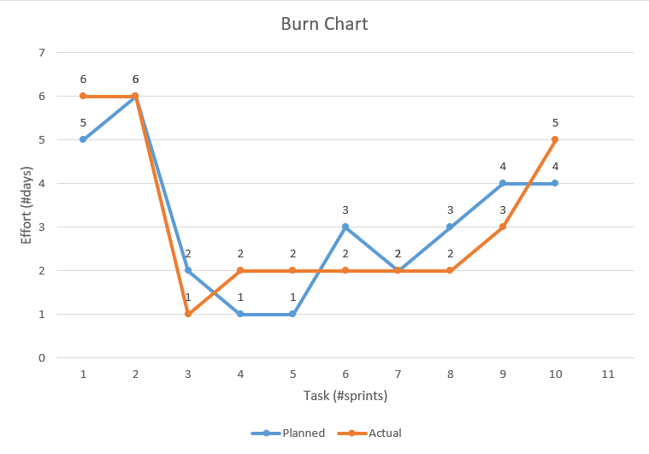

6. Proposed Enhancement:
- We will try to implement SMS functionality in our system when the stock is less and need to buy.
- Try to implement online so the other branch also gets info.
- Try to connect with automated product scanner machine so no need to type all information.
- Make a flexible website so all shop owner can set by own product and no need for a person to write all entry.

7. Conclusion:
This is an Inventory Management System which work for all kind of products like electronics, furniture and many more. We also can generate invoice bill and download as pdf which makes easy for shop owner to collect the data.
We wrap up this project, we have learned a lot about how inventory systems work and why they are so important for businesses. Our main goal was to create a system that is easy to use, grows with the business, and helps save time and money.
We focused on using simple tools like Php to build it.

8. Bibliography:
- www.google.com
- www.geeksforgeeks.org
- www.tutorialspoint.com
- www.w3school.com

